**VISVESVARAYA TECHNOLOGICAL UNIVERSITY**



**BELAGAVI-590018, KARNATAKA**

### A Web Technology Mini Project Report On

“DEPRESSION ANALYSIS WEBSITE”

### Submitted in Partial fulfillment of the Requirements for the VII Semester of the Degree of Bachelor of Engineering in Computer Science & Engineering

**By**

**ZEESHAN ISLAM (1CR17CS181)**

**SAI PRIYA (1CR17CS124)**

**Under the Guidance of, Prof. SHERLY NOEL**

**Assistant Professor, Dept. of CSE**

**CMR INSTITUTE OF TECHNOLOGY**

**DEPARTMENT OF COMPUTER SCIENCE & ENGINEERING**

#132, AECS LAYOUT, IT PARK ROAD, KUNDALAHALLI, BANGALORE-560037

**CMR INSTITUTE OF TECHNOLOGY**



#132, AECS LAYOUT, IT PARK ROAD, KUNDALAHALLI, BANGALORE-560037

### DEPARTMENT OF COMPUTER SCIENCE AND ENGINEERING

Certificate

This is to certify that the Technical Seminar Report entitled, **“Depression Analysis Website”**, prepared by **Zeeshan Islam,** bearing **USN 1CR17CS181**, **Sai Priya,** bearing **USN 1CR17CS124** the bonafide students of CMR Institute of Technology in partial fulfillment of the requirements for the award of **Bachelor of Engineering in Computer Science and Engineering** of the Visvesvaraya Technological University, Belagavi - 590018 during the academic year 2020-21.

It is certified that all the corrections and suggestions indicated for Internal Assessment have been incorporated in the report deposited in the departmental library. The seminar report has been approved as it satisfies the academic requirements prescribed for the said degree.

|  |  |
| --- | --- |
| **-----------------------** | **----------------------** |
| **Signature of Guide** | **Signature of HOD** |
| **Mrs. Sherly Noel** | **Dr. Prem Kumar Ramesh** |
| **Assistant Professor** | **Professor, Head** |
| **Dept. of CSE, CMRIT** | **Dept. of CSE, CMRIT** |
| **External Viva** | |
| **Name of the examiners** | **Signature with date** |
| **1.** |  |
| **2.** |  |

**ACKNOWLEDGEMENT**



We take this opportunity to express our sincere gratitude and respect to **CMR Institute**

**of Technology, Bengaluru** for providing us a platform to pursue our studies and carry out our web laboratory project.

We have a great pleasure in expressing our deep sense of gratitude to **Dr. Sanjay Jain,**

Principal, CMRIT, Bangalore, for his constant encouragement.

We would like to thank **Dr. Prem Kumar Ramesh,** HOD, Department of Computer

Science and Engineering, CMRIT, Bangalore, who has been a constant support and

encouragement throughout the course of this project.

We consider it a privilege and honor to express our sincere gratitude to our guide

**Mrs. Sherly Noel, Asst. Professor,** Department of Computer Science and Engineering, for

the valuable guidance throughout the tenure of this review.

We also extend our thanks to all the faculty of Computer Science and Engineering who

directly or indirectly encouraged us.

Finally, we would like to thank our parents and friends for all their moral support they

have given us during the completion of this work.

**ABSTRACT**



Web development is the process of building websites and applications for the internet, or for a private network known as an intranet. It is not concerned with the design of a website; rather, it’s all about the coding and programming that powers the website’s functionality. We have developed a website for our Web Development and Applications project, “Depression Analysis” using HTML5, CSS3, JavaScript, PHP7 and SQL. Project Management System provides evaluation in an easy and quick manner. It saves time and the process of evaluation and viewing the reports can be managed easily. This system provides an easy way to assess your mental health. Backed by an internationally accepted and used assessment for depression diagnosis (CES-D), this website makes it simple and straightforward to take this test for yourself, which would otherwise require payment at a hospital or center for psychology.



1. Chapter 1 –Introduction
   1. Objective Page -6
   2. System Study Page -6
   3. Existing System Page -8
   4. Proposed System Page -8
2. Chapter 2 – System Specifications
   1. Hardware Specifications Page -9
   2. Software Specifications Page -9
3. Chapter 3 – Design and Methodology
   1. HTML Page -10
   2. CSS Page -10
   3. JS Page -11
   4. PHP Page -12
   5. XAMPP Page-12
   6. Database Schema Page -13
4. Chapter 4 –Implementation
   1. Database Overview Page -15
   2. Sample Code Page -16
   3. Screenshots Page -20
5. Chapter 5–Conclusion Page -24
6. Chapter 6–References Page -25



|  |  |  |
| --- | --- | --- |
| Fig 1.1 | Waterfall Model | Page 7 |
| Fig 3.8 | Database Schema | Page 13 |
| Fig 3.9 | ER Diagram | Page 14 |
| Fig 4.1 | Database Overview | Page 15 |
| Fig 4.2 | Home page | Page 20 |
| Fig 4.3 | Sign Up page | Page 20 |
| Fig 4.4 | CESD Test | Page 21 |
| Fig 4.5 | Results - Depressed | Page 21 |
| Fig 4.6 | Results – Not Depressed | Page 21 |
| Fig 4.7 | About Us | Page 22 |
| Fig 4.8 | Resources | Page 22 |
| Fig 4.9 | Admin Login | Page 22 |
| Fig 4.10 | Admin Access Page | Page 23 |
| Fig 4.11 | Add Question | Page 23 |
| Fig 4.12 | Remove Question | Page 23 |

## CHAPTER 1

**INTRODUCTION**

* 1. **Objective**
     + To develop a website which will help users analyse their mental health.
     + The user will register and take a psychological test, the CES-D test to check if he has depression or not.
     + The project will provide the users to check their own mental state and will empower them on the topic of mental health.

## System study

The Process Model used in our project "Depression Analysis" is the waterfall model.

The Waterfall Model:

The waterfall model is a sequential design process, used in software development processes, in which progress is seen as flowing steadily downwards (like a waterfall) through the phases of Conception, Initiation, Analysis, Design, Construction, Testing, production/Implementation and maintenance

The waterfall development model originates in the manufacturing and construction industries: highly structured physical environments in which after-the-fact changes are prohibitively costly, if not impossible. Since no formal software development methodologies existed at the time, this hardware-oriented model was simply adapted for software development.

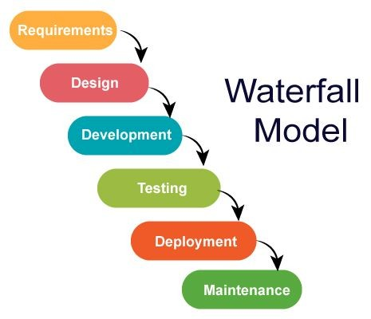

Figure 1.1 Waterfall Model

## Existing system

There isn’t any website which provides the user with a psychological test to analyze a person’s mental health. The current websites just provide self-help information and a helpline so that users can talk and share their problems with an expert.

## Proposed System

The proposed system provides evaluation in an easy and quick manner. It saves time and the process of evaluation and viewing the reports can be managed easily. This system is a complete one in all platform to allocate projects, assess and grant reports to the students based on their projects. This system also enables the users and doctors to interact with each other.

## CHAPTER 2

**SYSTEM SPECIFICATIONS**

* 1. **Hardware requirements**
     + **Processors**: Intel core i5
     + **Processor speed**: 1.80 GHz
     + **RAM**: 16 GB
     + **Storage**: 256 GB

## Software requirements

* + - **Operating system**: Windows
    - Bootstrap, HTML, CSS, PHP , JavaScript
    - **Web browser**: Google chrome

## CHAPTER 3

**DESIGN & METHODOLOGY**

* 1. **HTML**

**Hypertext Markup Language** (**HTML**) is the standard markup language for documents designed to be displayed in a web browser. It can be assisted by technologies such as Cascading Style Sheets (CSS) and scripting languages such as JavaScript.

Web browsers receive HTML documents from a web server or from local storage and render the documents into multimedia web pages. HTML describes the structure of a web page semantically and originally included cues for the appearance of the document.

HTML elements are the building blocks of HTML pages. With HTML constructs, images and other objects such as interactive forms may be embedded into the rendered page. HTML provides a means to create structured documents by denoting structural semantics for text such as headings, paragraphs, lists, links, quotes and other items.

HTML elements are delineated by *tags*, written using angle brackets. Tags such as

<**img** /> and <**input** /> directly introduce content into the page. Other tags such as <**p**> surround and provide information about document text and may include other tags as sub-elements. These tags should be placed underneath each other **at the top of every HTML page** that you create.

<!DOCTYPE html> — This tag **specifies the language** you will write on the page. In this case, the language is HTML 5.

<html> — This tag signals that from here on we are going to write in HTML code.

<head> — This is where all the **metadata for the page** goes — stuff mostly meant for search engines and other computer programs.

<body> — This is where the **content of the page** goes.

## CSS

**Cascading Style Sheets (CSS)** is a style sheet language used for describing the presentation of a document written in a markup language such as HTML. CSS is a cornerstone technology of the World Wide Web, alongside HTML and JavaScript.

CSS is designed to enable the separation of presentation and content, including layout, colors, and fonts.

This separation can improve content accessibility, provide more flexibility and control in the specification of presentation characteristics, enable multiple web pages to share formatting by specifying the relevant CSS in a separate .css file which reduces complexity and repetition in the structural content as well as enabling the .css file to be cached to improve the page load speed between the pages that share the file and its formatting.

The name *cascading* comes from the specified priority scheme to determine which style rule applies if more than one rule matches a particular element. This cascading priority scheme is predictable.

CSS (Cascading Style Sheets) is used to style and lay out web pages — for example, to alter the font, color, size, and spacing of your content, split it into multiple columns, or add animations and other decorative features.

A CSS comprises style rules that are interpreted by the browser and then applied to the corresponding elements in your document. A style rule is made of three parts −

* + - Selector − A selector is an HTML tag at which a style will be applied. This could be any tag like <h1> or <table> etc.
    - Property − A property is a type of attribute of HTML tag. Put simply, all the

HTML attributes are converted into CSS properties. They could be *color*, *border*

etc.

* + - Value − Values are assigned to properties. For example, *color* property can have value either *red* or *#F1F1F1* etc.

## Bootstrap

## Bootstrap is a free and open-source CSS framework directed at responsive, mobile-first front-end web

## development. It contains CSS- and (optionally) JavaScript-based design templates for typography, forms, buttons, navigation, and other interface components.

## Bootstrap is the seventh-most-starred project on GitHub, with more than 142,000 stars, behind freeCodeCamp (almost 312,000 stars) and marginally behind Vue.js framework.

## PHP

The PHP Hypertext Preprocessor (PHP) is a programming language that allows web developers to create dynamic content that interacts with databases. PHP is basically used for developing web-based software applications. This tutorial helps you to build your base with PHP.

PHP is a MUST for students and working professionals to become a great Software Engineer specially when they are working in Web Development Domain.

It is integrated with a number of popular databases, including MySQL, PostgreSQL, Oracle, Sybase, Informix, and Microsoft SQL Server.

PHP is one of the most widely used languages over the web. I'm going to list few of them here:

* + - PHP performs system functions, i.e. from files on a system it can create, open, read, write, and close them.
    - PHP can handle forms, i.e. gather data from files, save data to a file, through

email you can send data, return data to the user.

* + - You add, delete, modify elements within your database through PHP.
    - Access cookies variables and set cookies.
    - Using PHP, you can restrict users to access some pages of your website.
    - It can encrypt data.

## JavaScript

## JavaScript, often abbreviated as JS, is a programming language that conforms ECMAScript specification. JavaScript is high-level, often just-in-time compiled, and multi-paradigm. It has curly bracket syntax, dynamic typing, prototype-based object-orientation, and first-class functions.

## Alongside HTML and CSS, JavaScript is one of the core technologies of the World Wide Web. JavaScript enables interactive web pages and is an essential part of web applications. The vast majority of websites use it for client-side page behavior, and all major web browsers have a dedicated JavaScript engine to execute it.

## 3.7 XAMPP or other frameworks

XAMPP is an abbreviation where *X stands for Cross-Platform, A stands for Apache, M stands for MYSQL, and the Ps stand for PHP and Perl*, respectively. It is an

open-source package of web solutions that includes Apache distribution for many

servers and command-line executables along with modules such as Apache server, MariaDB, PHP, and Perl.

XAMPP helps a local host or server to test its website and clients via computers and laptops before releasing it to the main server. It is a platform that furnishes a suitable environment to test and verify the working of projects based on Apache, Perl, MySQL database, and PHP through the system of the host itself. Among these technologies, Perl is a programming language used for web development, PHP is a backend scripting language, and MariaDB is the most vividly used database developed by MySQL.

## 3.8 Database Schema

## Figure 3.1 User Details

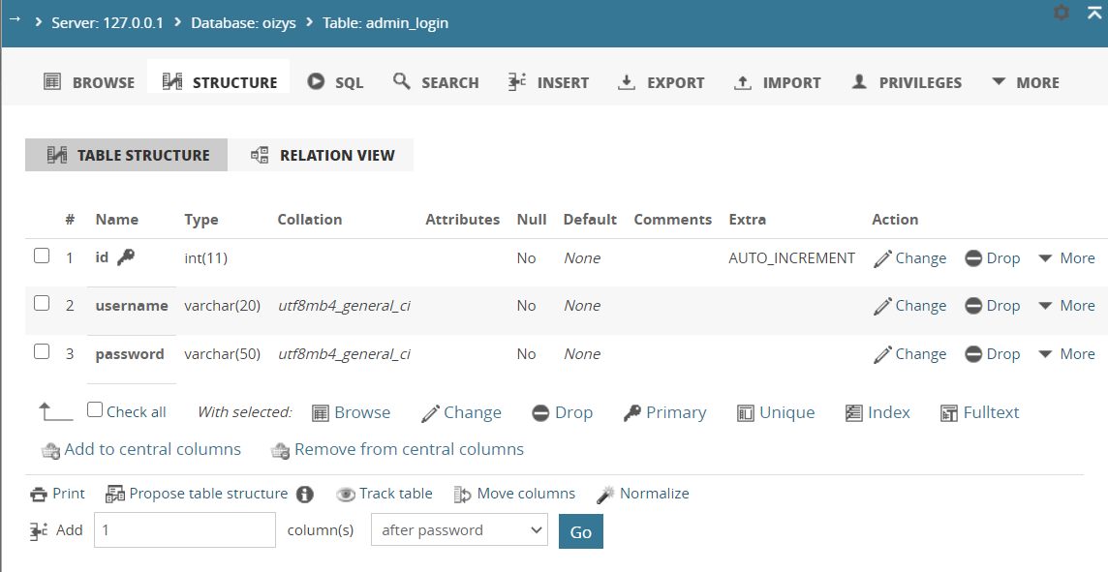Figure 3.2 CES-D

Figure 3.3 admin-login

## 3.9 E-R Diagram

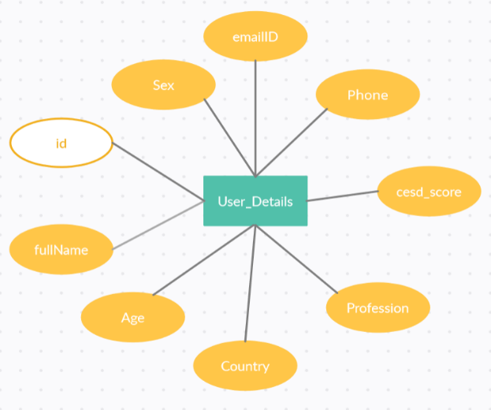

## 

Figure 3.1 User Details

## Figure 3.2 CES-D

Figure 3.3 Admin Login

## CHAPTER 4

**IMPLEMENTATION**

**4.1 DATABASE OVERVIEW**

For this project, we have used a database (named **Oizys**) comprising of 3 tables. The first table, called **user_details** is used to store the personal details of the test taker. This includes their full name, age, sex, email ID, phone number, country and profession. The second table, called **admin-login** is to store the admin login information, viz., the username and password. The third table, called **CESD** is used to store the questions present in the test, along with the respective points for each option. All three tables have a primary key ID, which is auto incremented.

## Sample Code

## index.html

<!DOCTYPE html>

<html lang="en">

<head>

    <meta charset="UTF-8">

    <meta name="viewport" content="width=device-width, initial-scale=1.0">

    <title>Home</title>

    <!-- Google Fonts -->

    <link href="https://fonts.googleapis.com/css2?family=Merriweather:wght@400;700&family=Poppins:wght@300;500;600;700;800&family=Satisfy&display=swap" rel="stylesheet">

    <!-- CSS Stylesheets -->

    <link rel="stylesheet" href="https://stackpath.bootstrapcdn.com/bootstrap/4.5.2/css/bootstrap.min.css" integrity="sha384-JcKb8q3iqJ61gNV9KGb8thSsNjpSL0n8PARn9HuZOnIxN0hoP+VmmDGMN5t9UJ0Z" crossorigin="anonymous">

    <link rel="stylesheet" href="styles.css">

    <!-- Font Awesome -->

    <script defer src="https://use.fontawesome.com/releases/v5.0.7/js/all.js"></script>

    <!-- Bootstrap scripts -->

    <script src="https://code.jquery.com/jquery-3.5.1.slim.min.js" integrity="sha384-DfXdz2htPH0lsSSs5nCTpuj/zy4C+OGpamoFVy38MVBnE+IbbVYUew+OrCXaRkfj" crossorigin="anonymous"></script>

    <script src="https://cdn.jsdelivr.net/npm/popper.js@1.16.1/dist/umd/popper.min.js" integrity="sha384-9/reFTGAW83EW2RDu2S0VKaIzap3H66lZH81PoYlFhbGU+6BZp6G7niu735Sk7lN" crossorigin="anonymous"></script>

    <script src="https://stackpath.bootstrapcdn.com/bootstrap/4.5.2/js/bootstrap.min.js" integrity="sha384-B4gt1jrGC7Jh4AgTPSdUtOBvfO8shuf57BaghqFfPlYxofvL8/KUEfYiJOMMV+rV" crossorigin="anonymous"></script>

</head>

<body>

    <section class="coloured-section" id="title">

      <!-- Navigation Bar -->

      <nav class="navbar navbar-expand-lg navbar-dark">

        <a class="navbar-brand" href="index.html">Oizys</a>

        <button class="navbar-toggler" type="button" data-toggle="collapse" data-target="#navbarSupportedContent" aria-controls="navbarSupportedContent" aria-expanded="false" aria-label="Toggle navigation">

          <span class="navbar-toggler-icon"></span>

        </button>

        <div class="collapse navbar-collapse" id="navbarSupportedContent">

          <ul class="navbar-nav ml-auto">

            <li class="nav-item">

                <a class="nav-link" href="resources.html">Resources</a>

            </li>

            <li class="nav-item">

              <a class="nav-link" href="about-us.html">About Us</a>

            </li>

            <li class="nav-item">

              <a class="nav-link" href="admin-login.html">Admin</a>

            </li>

          </ul>

        </div>

      </nav>

      <div class="container-fluid">

        <!-- Title -->

            <h1 class="title-text">Mental Health Analysis</h1>

        <a href="./signup.html"><button type="submit" class="input-button btn btn-outline-light btn-lg">Take the Test!</button>

        </a>

      </div>

    </section>

    <section class="white-section" id="information">

      <!-- cards -->

      <h2 class="info-headings">Confused?</h2>

      <p>This should help you understand better.</p>

      <div class="row">

        <div class="info-column col-lg-4 col-md-6">

          <div class="card"> <!--1-->

            <div class="card-body">

              <h2 class="info-headings">What?</h2>

              <p>This super simple tool tells you if you may have depression or not based on an internationally recognized depression screening test.</p>

            </div>

          </div>

        </div>

        <div class="info-column col-lg-4 col-md-6">

          <div class="card"> <!--2-->

            <div class="card-body">

              <h2 class="info-headings">Why?</h2>

              <p>Mental Health is very important. Most communities across the world have a stigma around mental health. This is our attempt to break the stigma. Many people who may have depression hesitate to directly show up at a therapist's office. Using a tool like this can give a push in the right direction, so to speak.</p>

            </div>

          </div>

        </div>

        <div class="info-column col-lg-4">

          <div class="card"> <!--3-->

            <div class="card-body">

              <h2 class="info-headings">How?</h2>

              <p>The test is quite simple. We’re using a test that is widely used for depression and mental health screening by the Center of Epidemiologic Studies for Depression (CES-D). There are 20 questions, each with 4 options. All you have to do is answer them honestly and you will get a score that indicates whether you may or may not be depressed. </p>

            </div>

          </div>

        </div>

      </div>

    </section>

    <footer class="footer coloured-section ">

        <p class="footer-text">This is a project created by Sai Priya and Zeeshan Islam.</p>

        <p>© Copyright 2020 Oizys</p>

    </footer>

</body>

</html>

## 4.3 Screenshots

Figure 4.3 – Sign Up page

Figure 4.2 – Home page

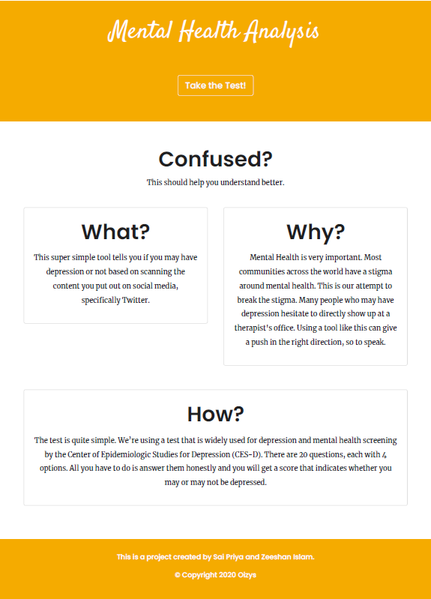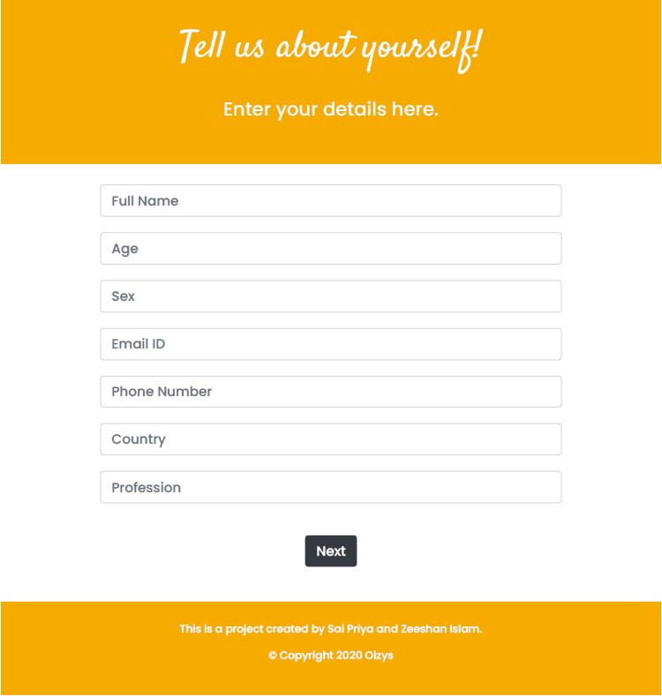

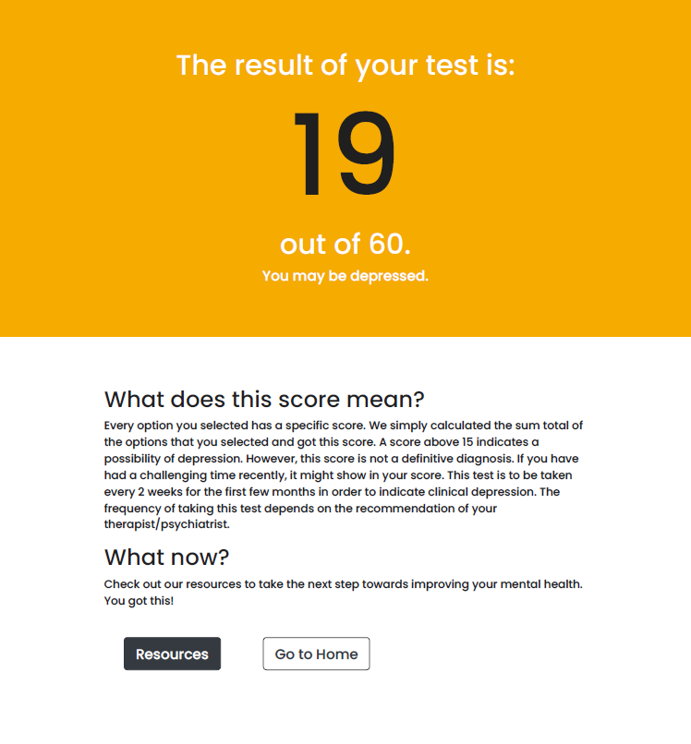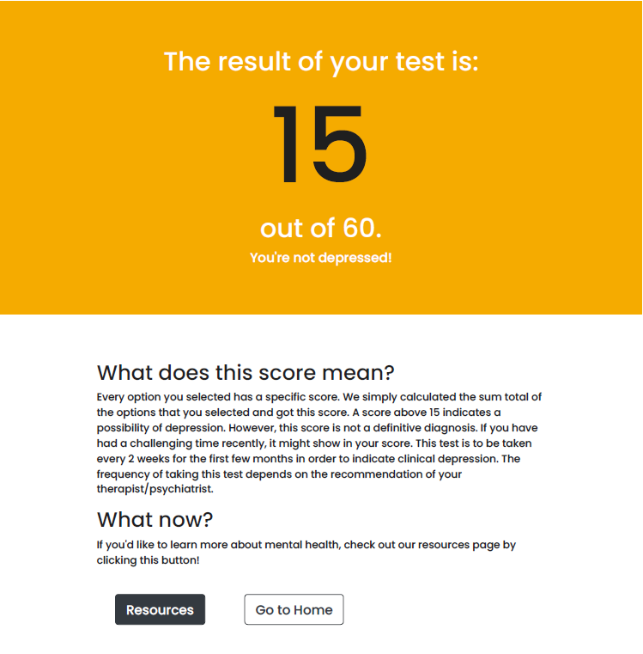

Figure 4.5 – Results (Depressed)

Figure 4.6 – Results (Not Depressed)

Figure 4.4 – CESD Test

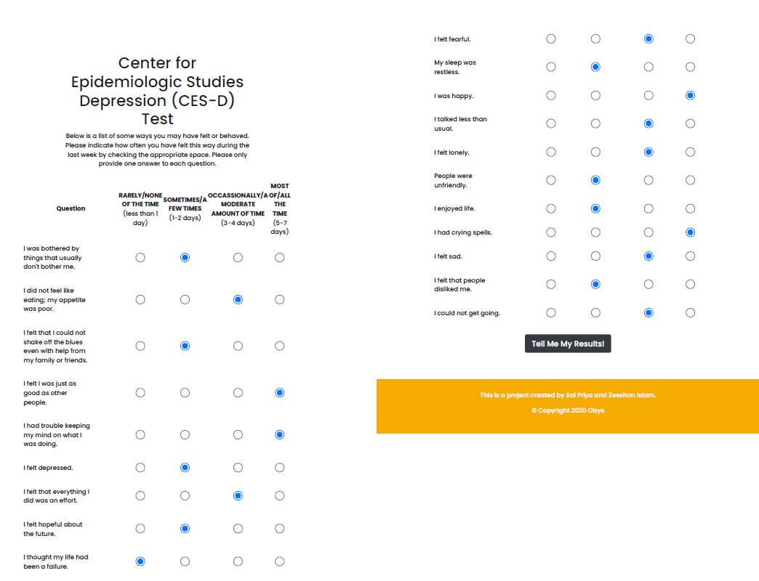

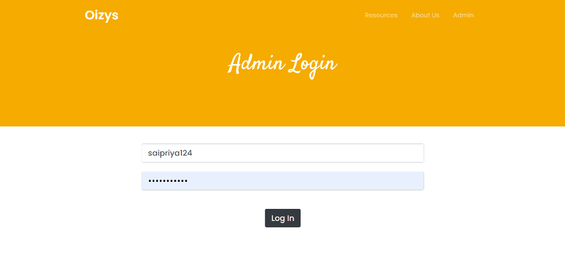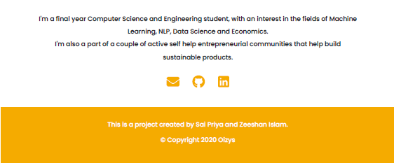

Figure 4.9 – Admin Login

Figure 4.8 – Resources

Figure 4.7 – About Us

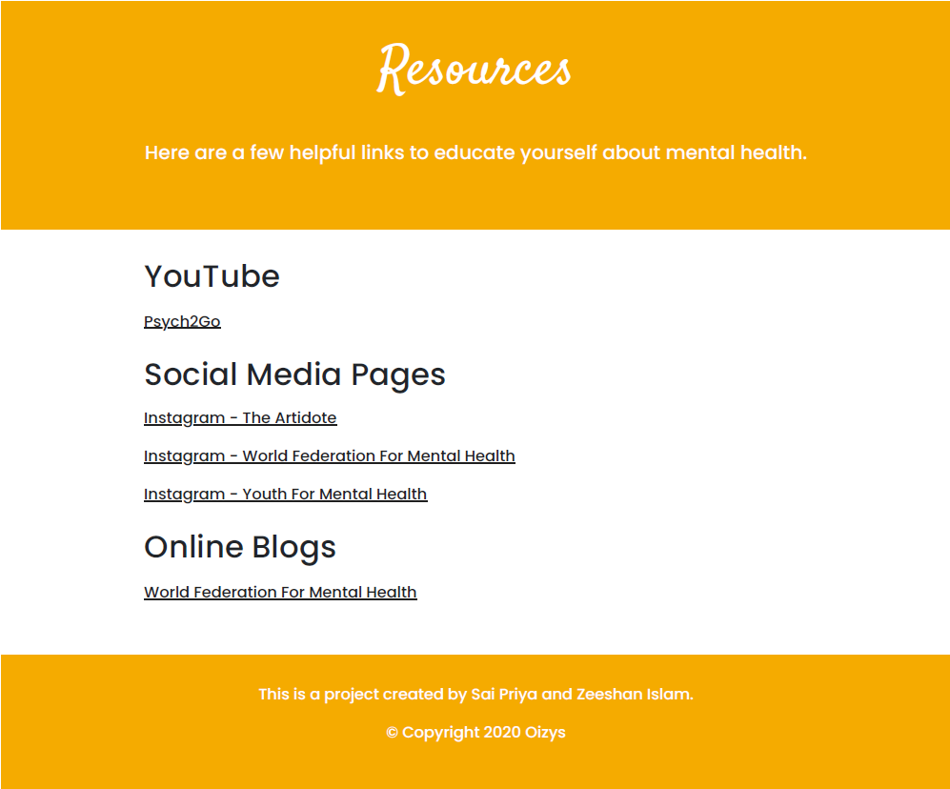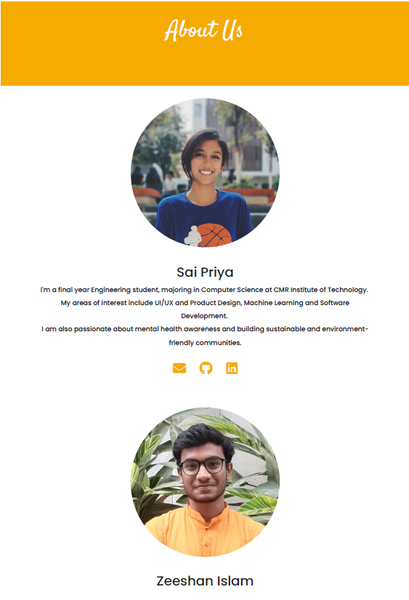

## 

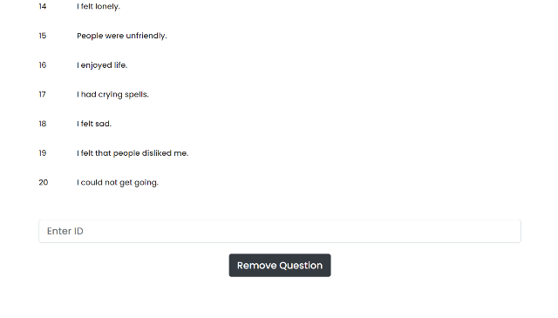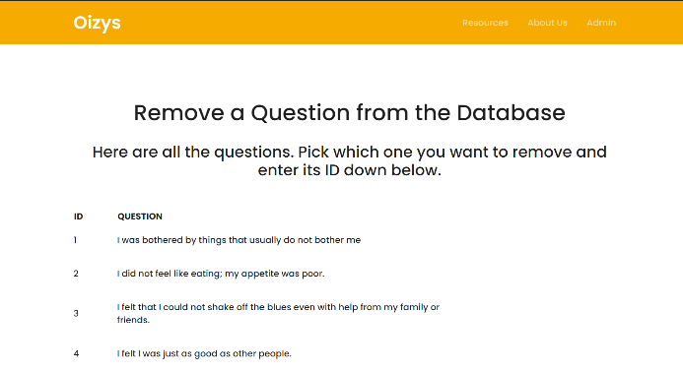

Figure 4.12 – Remove Question

Figure 4.11 – Add Question

Figure 4.10 – Admin Access Page

## CHAPTER 5

**CONCLUSION**

This project will help in futuristic prediction of depression and will provide the target audience a self-service tool to assess and get an idea about their own mental health. Psychologists will be able to use this tool to test it on their patients, and in the future, this website can use sentiment analysis to analyse a person through their online content, to provide more accuracy to the diagnosis.

## CHAPTER 6

## REFERENCES

## 4.2.1 <https://docs.w3cub.com>

## 4.2.2 <https://www.w3schools.com>

## 4.2.3 <https://getbootstrap.com>

## 4.2.4 <https://stackoverflow.com>

## 4.2.5 <https://youtube.com>